Experiment No. 10

Lab 10 – Introduction to Files

**Programming Exercise**

1. Write a function stats() that takes one input argument: the name of a text file. The

function should print, on the screen, the number of lines, words, and characters in the file. your function should open the file only once

**CODE:**

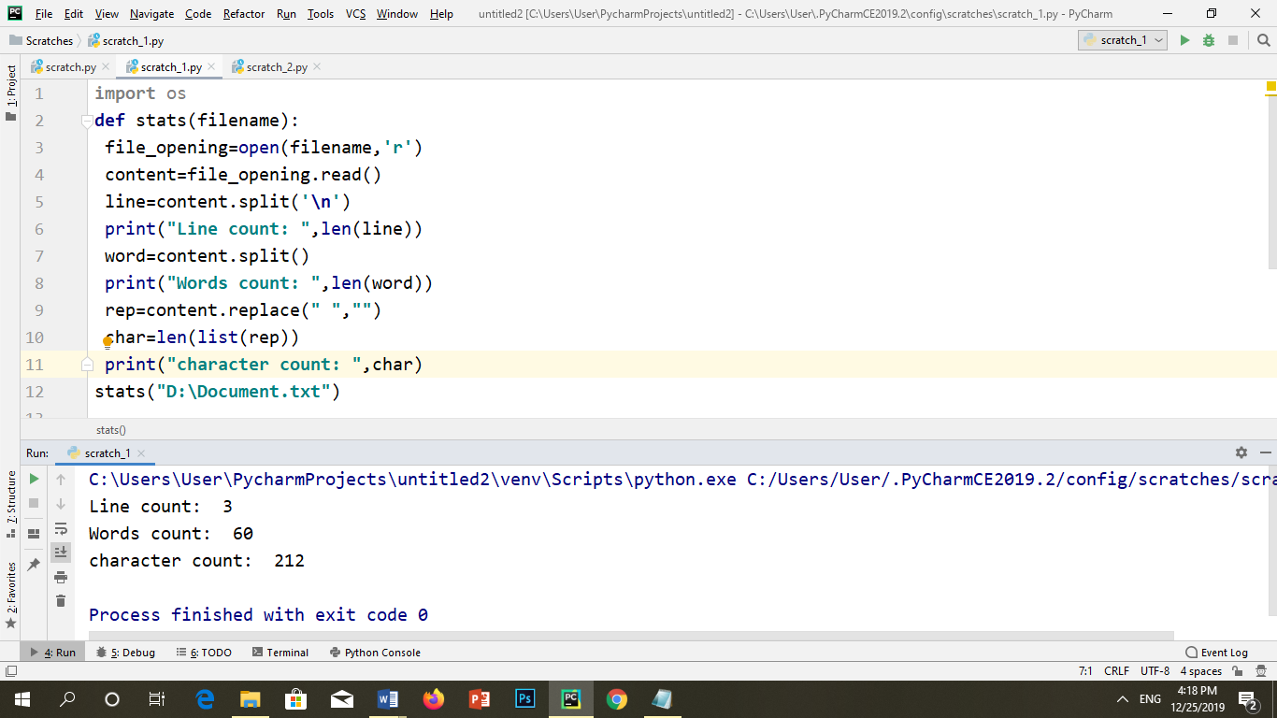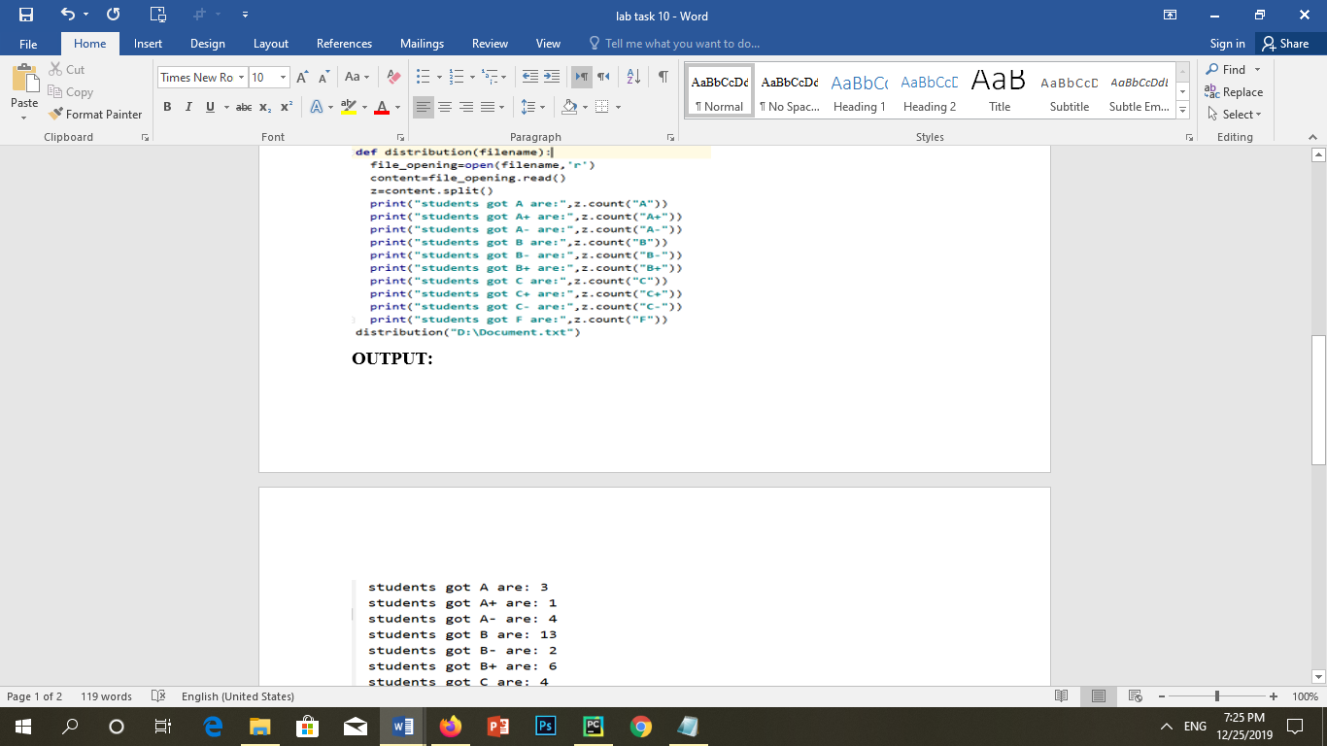



2. Implement function distribution() that takes as input the name of a file (as a string). This one-line file will contain letter grades separated by blanks. Your function should

.print the distribution of grades.

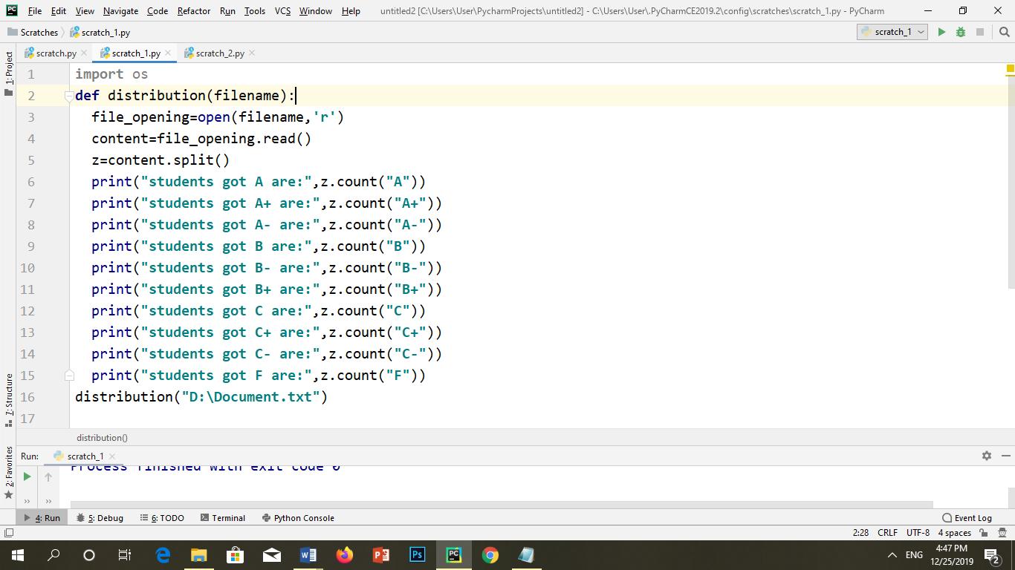**CODE:**

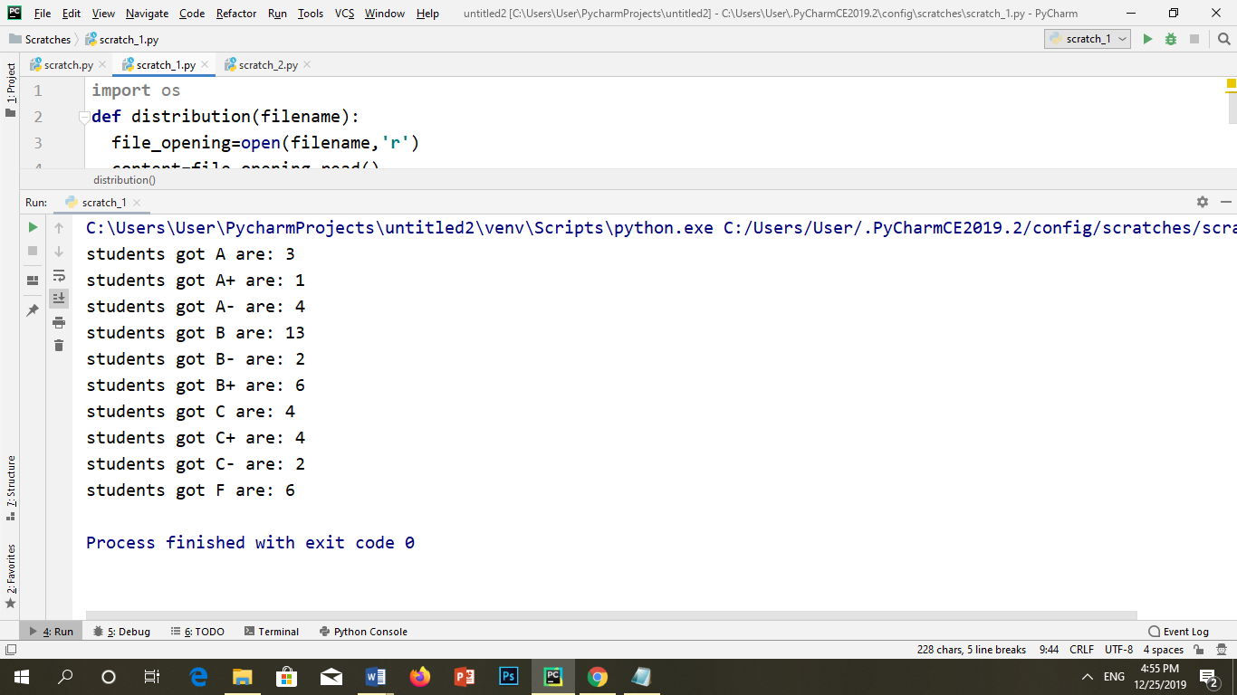

3. Implement function duplicate() that takes as input the name (a string) of a file in the

.current directory and returns True if the file contains duplicate words and False otherwise

**CODE:**

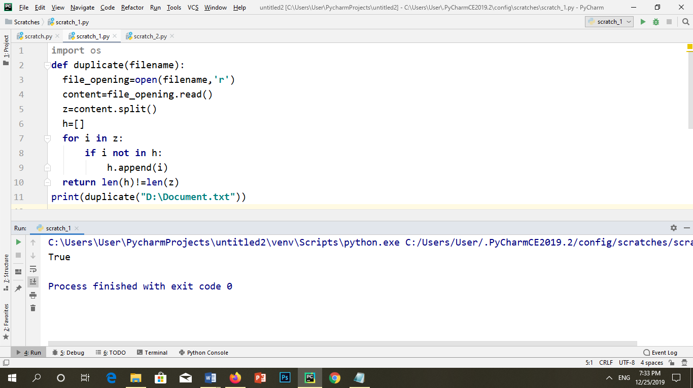

4.The function abc() takes the name of a file (a string) as input. The function should .4 open the file, read it, and then write it into file abc.txt with this modification: Every

'occurrence of a four-letter word in the file should be replaced with string'xxxx abc('example.txt') >>>

Note that this function produces no output, but it does create file abc.txt in the current folder

**CODE:**

